Although finance is an essential function in every company, finance teams spend too much time gathering data, staring at spreadsheets, completing the close, and generating reports.

Digital tools can reduce and even eliminate these tasks, freeing up finance to add more value as a strategic business partner.

**Business Case**: Automated Expense Categorization

**Objective:** The objective is to develop an automated system that categorizes business expenses from accounts payable transaction history, streamlining the bookkeeping process and enhancing financial analysis accuracy.

**Problem Statement:** Manual expense categorization is time-consuming, prone to human error, and inefficient, leading to inconsistencies in financial reporting and delayed decision-making (step 2&3 below))

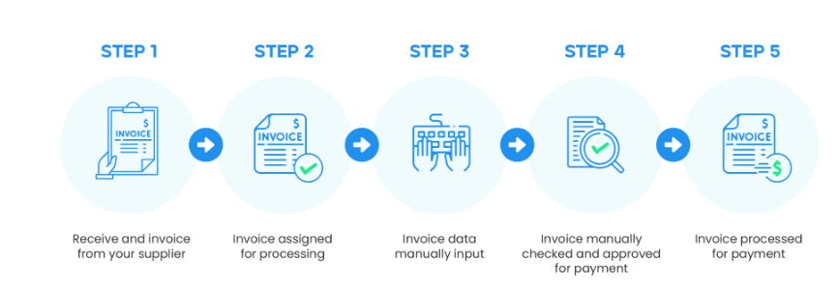

<https://planergy.com/blog/accounts-payable-cycle/>

**Proposed Solution** An automated system leveraging machine learning will categorize expenses based on transaction descriptions. This will reduce processing time and increase accuracy.

**Use Case:** A.Qureshi submits an invoice for $100K. Accounting Clerk must determine what project/department received the service (say average 12 minutes). If ML could predict the department served by Ms.Qureshi based on previous invoices the clerks processing time might be reduced to say 9 minutes. Let’s hire an accounting clerk for $50K per annum to process 10k transaction lines per year, a 25% reduction saves $12.5K a year, and gives the clerk more time to analyse the accounts payable results.

**Benefits:**

Efficiency: Reduces manual effort and time in expense tracking.

Accuracy: Minimizes human errors, ensuring consistent financial records.

Scalability: Easily handles growing transaction volumes.

**Key Technologies**: Python Pandas, Scikit-learn, JavaScript Plotly.

**Data** : Data extracted from a project team. Sensitive data has been removed  
anonoymous_invoice.csv

Meta Date

|  |  |  |
| --- | --- | --- |
| Field name | Description | Data Type |
| Vendor | Company/person sold goods/services to company | Varchar(50) |
| Invoice$ | Value to be paid to vendor | Decimal (2) |
| Description | Text explaining the good/service sold | Varchar(250) |
| Date | Invoice date | Date |
| Internal number | Company supplied number/name to Vendor (i.e. buyer name /purchase order | VarChar(50) |
| Unit Cost | Cost of good/service | Decimal (2) |

Input Black box Final output

Vendor  
description   
invoice number  
 Goes to approval

(flask/website/….)

Thoughts

-creates bins for vendor /description

-key words in description to predict who will approve

- Unit cost could identify the product/service purchased

-